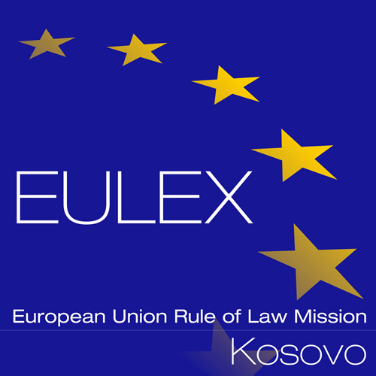

European Union Rule of Law Mission in Kosovo
EULEX Kosovo
Lidhja e Pejës, Industrial Zone P.O. Box 268
10000 Pristina, Kosovo
www.eulex-kosovo.eu

CORRIGENDUM NUMBER 1

TO THE CONTRACT NOTICE

PUBLICATION REFERENCE: PROC/1308/24/Fuel Supply no.10

The following corrections are made to the Contract Notice
- SECTION I, INSTRUCTIONS TO TENDERERS, POINT IV.2.2) and IV.2.7)

The former text:

IV.2.2) Time limit for submission of tenders

On 12/11/2024 at 14:00hrs, (Kosovo time zone) at EULEX, Procurement Unit, Lidhja e Pejës, Industrial Zone, P.O. Box 268, 10000 Pristina, Kosovo.

Shall read now:

IV.2.2) Time limit for submission of tenders

On 14/01/2025 at 14:00hrs, (Kosovo time zone) at EULEX, Procurement Unit, Lidhja e Pejës, Industrial Zone, P.O. Box 268, 10000 Pristina, Kosovo.

The former text:

IV.2.7) Conditions for opening of tenders
Date: 12/11/2024
Local time: 14:30 hrs (Kosovo time zone)
Place:
EULEX Kosovo – Procurement Unit
Lidhja e Pejës, Industrial Zone, P.O. Box 268

10000 Pristina, Kosovo

Shall read now:

IV.2.7) Conditions for opening of tenders
Date: 14/01/2025
Local time: 14:30 hrs (Kosovo time zone)
Place:
EULEX Kosovo – Procurement Unit
Lidhja e Pejës, Industrial Zone, P.O. Box 268

10000 Pristina, Kosovo

EoT

